**Proposal  
Document**

**BigBag - Desktop Application**

SEP

# Table Of Contents

Table Of Contents 1

Problem Statement 2

Problem Solution and Scope 2

Basic Features 2

Project Plan 3

Modular Breakdown 3

Team Members & Roles 3

Prototypes 4

# 

# Problem Statement

In today's increasingly complex financial landscape, efficient and user-friendly financial management tools are paramount. Many individuals struggle to maintain a clear and organized view of their finances, leading to confusion, missed opportunities, and potential financial instability. Developing and adhering to budgets is often a daunting task, resulting in overspending, inadequate savings, and financial stress. Limited access to comprehensive investment insights and analysis leaves users uncertain about their investment decisions, potentially leading to missed opportunities and suboptimal returns. Navigating the complexities of tax regulations is a significant challenge for both individuals and businesses, often resulting in compliance issues, penalties, and lost deductions. Many users lack the financial knowledge required to make informed decisions, plan for their future, and secure their financial well-being.

# Problem Solution and Scope

BigBag will empower users to effortlessly track their expenses, record various sources of income, and effectively categorize their expenditures. With the ability to create customized spending categories and set monthly or yearly budgets, users will gain greater control over their financial health. The app will offer robust expense analytics, including detailed reports and visually appealing graphs, offering users invaluable insights into their spending patterns and financial habits. Furthermore, BigBag will support multiple currencies to cater to an international user base, ensuring that users from across the globe can benefit from its features. Security and data privacy will be paramount, with the implementation of secure user login and encryption mechanisms to safeguard user information.

# Basic Features

* **Expense Recording:**

Users can input expenses, including the amount, date, currency, and category.

* **Income Tracking**:

Record various sources of income with descriptions.

* **Expense Categories**:

Create and manage custom spending categories.

* **Budget Management:**

Set and monitor monthly or yearly budgets for different expense categories.

* **Expense Analytics:**

Generate detailed reports to visualize spending habits.

* **Currency Conversion**:

Support for multiple currencies to accommodate international users.

* **Data Security:**

Implement secure user authentication and data encryption for privacy.

# Project Plan

### Modular Breakdown

|  |  |  |
| --- | --- | --- |
| **Iteration** | **Module** | **Deliverables & Features** |
| 0 | Project Plan | -Problem Statement  -Problem Solution  -Discussing Basic Features  -What makes u Different  -Prototype |
| 1 | User Management & Security | - User registration/login - Data encryption  - Basic profile management |
| 2 | Expense & Income Management | - Expense recording (amount, date, currency, category)  - Income tracking  - Custom expense categories creation |
| 3 | Budgeting and Analytics | - Budget setting & monitoring for expense categories  - Expense analytics (reports & graphs)  - Currency conversion feature |

### Team Members & Roles

|  |  |
| --- | --- |
| **Name** | **Role** |
| Ali Hashim | Requirement Engineer & Lead Developer |
| Ayyan Ahmad | Project Lead, Designer & Architect |
| Hamza Jaffer | Developer & Tester |

# Prototype:

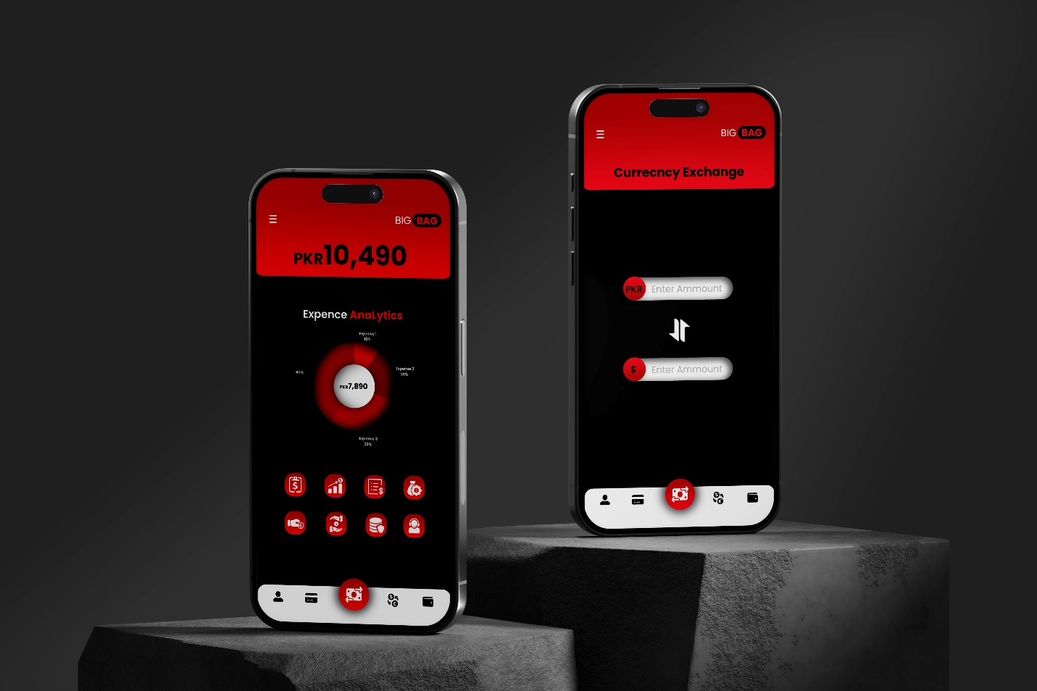

**USER STORIES FOR**

**User Management & Security Module:**

**Story ID:** 1

**Title:** User registration

As a new user, I want to register with my email and password, so I can access the application

securely.

**Acceptance Criteria:**

* User enters valid email and password.
* System verifies the email format and password strength.
* User receives a confirmation email for successful registration.

**Story ID:** 2

**Title:** User login Management

As a registered user, I want to log in using my credentials, so I can access my account and data securely.

**Acceptance Criteria:**

* User provides valid email and password.
* System verifies the credentials and grants access if they are correct.
* User sees their dashboard upon successful login.

**Story ID:** 3

**Title:** Data encryption

As a user, I want my data (such as passwords and sensitive information) to be encrypted, ensuring security and privacy.

**Acceptance Criteria:**

* System encrypts user passwords and sensitive data using industry-standard encryption algorithms.
* Encrypted data is securely stored and can only be decrypted with the correct keys.
* Users can access and modify their data securely.

**Story ID:** 4

**Title:** Basic profile management

As a user, I want basic profile management features to update my personal information.

**Acceptance Criteria:**

* User can edit and save their profile information, including name, email, and contact details.
* Changes made to the profile are reflected accurately throughout the application.
* Users can view their updated profile information after saving changes.

**USER STORIES FOR**

**Expense & Income Management Module:**

**Story ID:** 1

**Title:** Expense recording (amount, date, currency, category)

As a user, I want to record my expenses, including amount, date, currency, and category, for better financial tracking.

**Acceptance Criteria:**

* User can enter expense details such as amount, date, currency, and select a category.
* System stores the expense data securely and associates it with the user's account.
* Users can view a list of their recorded expenses and filter them by date or category.

**Story ID:** 2

**Title:** - Income tracking

As a user, I want to track my income sources to monitor my overall financial status.

**Acceptance Criteria:**

* User can add income details such as amount, date, and source.
* Income data is stored securely and displayed alongside expense data.
* Users can view a summary of their total income over a specific period.

**Story ID:** 3

**Title:** Custom expense categories creation

As a user, I want the ability to create custom expense categories to organize my expenses better.

**Acceptance Criteria:**

* User can create new expense categories and assign expenses to them.
* System allows for editing and deleting custom categories as needed.
* Custom categories are displayed in the expense management section for easy access.

**Structured Specifications of User Stories:**

User Management & Security Module:

* **User Registration/Login:**

**Input:** User enters a valid email address and password during registration.

**Process**: The system validates the email format and password strength.

If validation passes, the system generates a confirmation email and sends it to the user.

**Output**: User receives a confirmation email for successful registration.

* **Data Encryption:**

Input: User inputs sensitive data such as passwords or personal information.

Process: The system encrypts the data using industry-standard encryption algorithms.

Encrypted data is securely stored in the database.

Output: Encrypted data is stored securely and can only be decrypted with the correct keys.

* **Basic Profile Management:**

**Input:** User modifies their profile information (e.g., name, email, contact details).

**Process:** User updates the desired fields in the profile.

The system validates the changes and updates the database.

**Output**: Updated profile information is displayed to the user.

Expense & Income Management Module:

* **Expense Recording:**

**Input:** User enters expense details (amount, date, currency, category).

**Process:** The system validates the entered data for accuracy and completeness.

Validated data is stored securely in the database.

**Output**: User sees a confirmation of the recorded expense.

* **Income Tracking:**

**Input**: User adds income details (amount, date, source).

**Process:** The system verifies the entered data and stores it in the income records.

Income data is associated with the user's account for tracking purposes.

**Output:** User receives confirmation of the added income.

* **Custom Expense Categories Creation:**

**Input**: User creates new expense categories.

**Process:** User provides a name and description for the new category.

The system adds the category to the list of available expense categories.

**Output:** Newly created expense categories are visible for selection during expense recording.

**SUB- USER STORIES**

1. **User Management & Security: User Registration/Login**

**Sub-User Story 1:**

As a new user, I want to register an account with my email and password so that I can access the system securely.

**Acceptance Criteria:**

* I can navigate to the registration page from the home screen.
* I must provide a valid email address and a password containing at least 8 characters, including uppercase, lowercase letters, numbers, and special characters.
* Upon successful registration, I receive a confirmation email to verify my account.

**Sub-User Story 2:**

As a registered user, I want to log in to my account using my credentials to access personalized features.

**Acceptance Criteria:**

* I can access the login page from the home screen.
* I must enter my registered email and password to log in.
* After successful login, I am redirected to my dashboard with personalized options.

1. **Data Encryption**

**Sub-User Story 1:**

As a system administrator, I want to implement encryption algorithms to secure user data stored in the database.

**Acceptance Criteria:**

* Data such as passwords and sensitive user information must be encrypted using AES-256 encryption before storage.
* Only authorized users with decryption keys can access and view encrypted data.

1. **Basic Profile Management**

**Sub-User Story 1:**

As a logged-in user, I want to update my profile information such as name, email, and password.

**Acceptance Criteria:**

* I can navigate to the profile settings page from the dashboard.
* I can edit my name, email address, and password.
* Changes to the profile are saved and reflected in the system.

**Sub-User Story 2:**

As a user, I want to upload a profile picture to personalize my account.

**Acceptance Criteria:**

* I can upload an image file from my device on the profile settings page.
* The uploaded profile picture is displayed on my dashboard and account information.

1. **Expense & Income Management**

**Sub-User Story 1:**

As a user, I want to record my expenses by entering details such as amount, date, currency, and category.

**Acceptance Criteria:**

* I can access the expense recording feature from the dashboard.
* I enter the amount, date, currency (if applicable), and select a category for the expense.
* The recorded expense is saved and visible in my expense history.

**Sub-User Story 2:**

As a user, I want to track my income by entering details such as amount, date, and source.

**Acceptance Criteria:**

* I can access the income tracking feature from the dashboard.
* I enter the amount, date, and source of income.
* The recorded income is saved and visible in my income history.

**Sub-User Story 3:**

As a user, I want the ability to create custom expense categories to organize my expenses better.

**Acceptance Criteria:**

* I can navigate to the custom categories section from the expense management page.
* I create a new custom category with a unique name and description.
* The custom category is added to the list of available categories for expense recording

**Scrum Board**

**Functional Requirement Specifications**

|  |  |
| --- | --- |
| **Title** | **Description** |
| **User Registration/Login** | Users can create new accounts and log in securely. |
| **Data Encryption** | User data, especially sensitive information, is encrypted to ensure confidentiality |
| **Basic Profile Management** | Users can manage their basic profile information such as name, email, and password |
| **Expense Recording** | Users can record expenses including amount, date, currency, and category. |
| **Income Tracking** | Users can track their income sources. |
| **Custom Expense Categories Creation** | Users can create custom categories for expenses to better organize their financial data. |

**Non Functional Requirement Specifications**

**(NFR)**

|  |  |
| --- | --- |
| **Title** | **Description** |
| **Performance** | The system should respond quickly to user actions such as logging in, recording expenses, and accessing profile information. |
| **Security** | User data must be securely stored and transmitted to prevent unauthorized access or data breaches. |
| **Usuability** | The system should be user-friendly, with intuitive interfaces for tasks like registration, login, expense recording, and profile management |
| **Reliability** | The system should be reliable, with minimal downtime and robust error handling. |
| **Scalibility** | The system should be scalable to accommodate a growing user base and increasing data volume. |
| **Compatibility** | The system should be compatible with different devices, browsers, and operating systems. |
| **Maintainability** | The system should be easy to maintain and update over time. |

**Itteration 1 Implementaion**

**Email Validation**

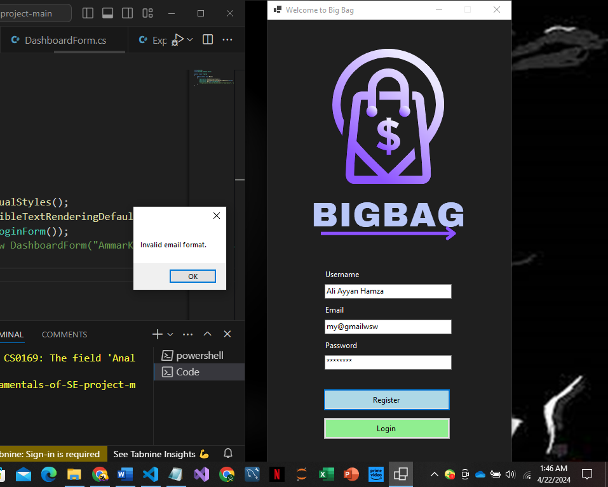

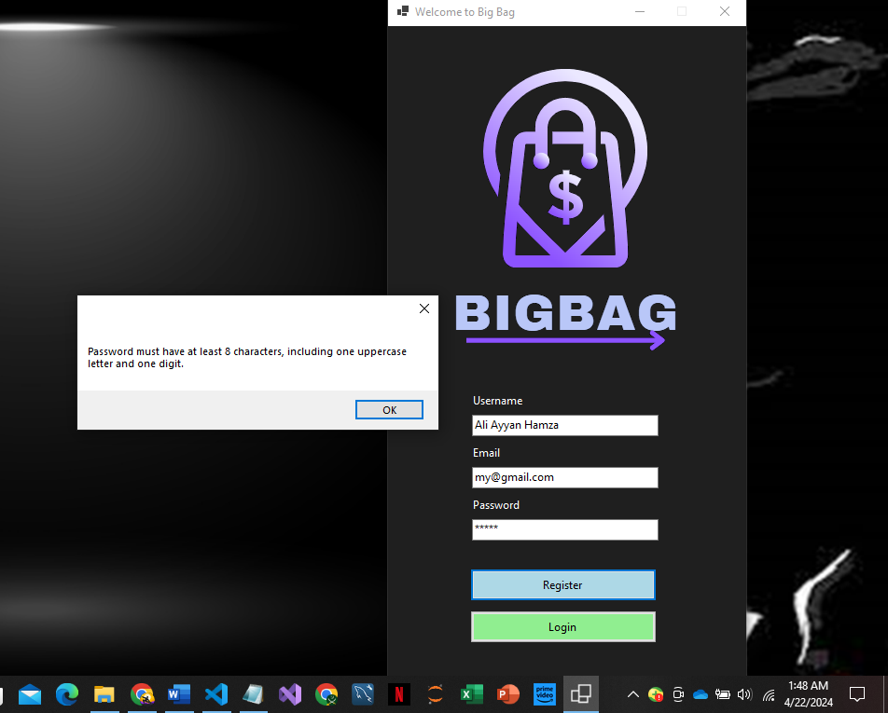

**Password Validation**

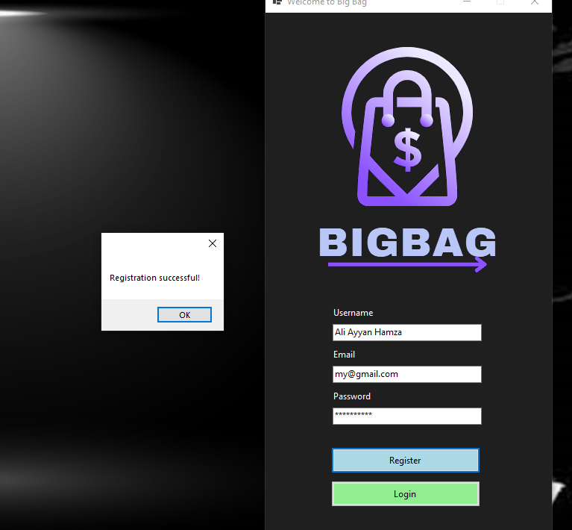

**Login**

**Dashboard**

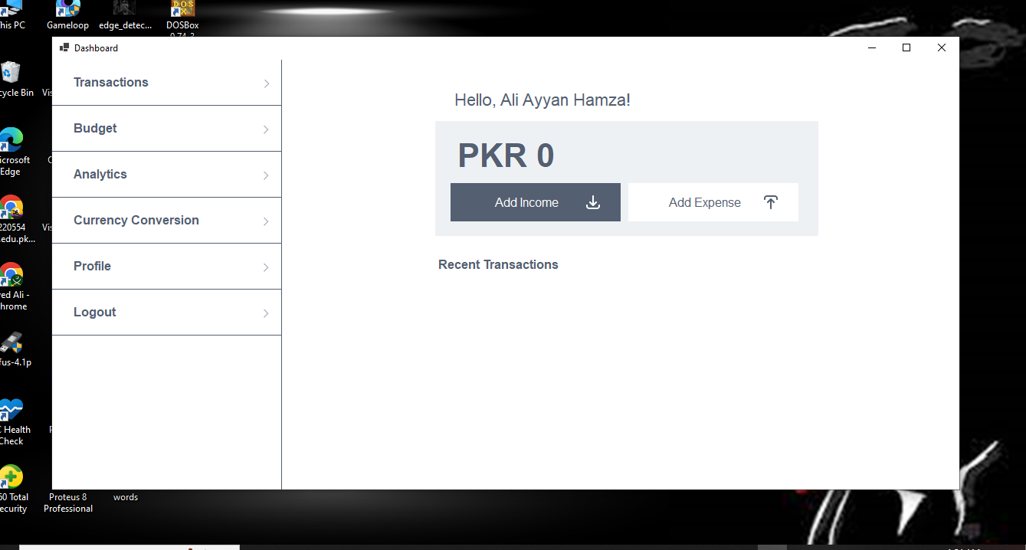

**Profile Mnaagment**

**Expense Record**

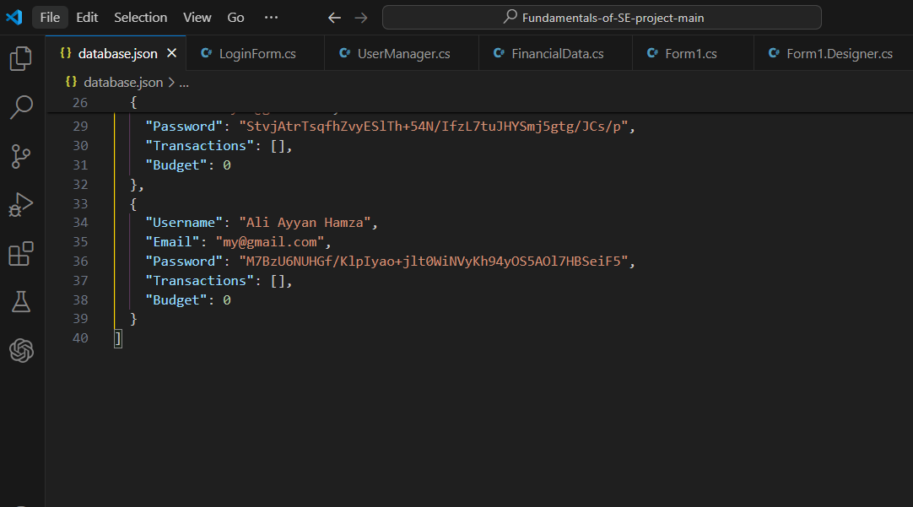**Database**